**CardioCare**

Tayyaba Afzal (2022-CS-134)

Raveeha Mohsin (2022-CS-149)

Software Requirements Specification Document

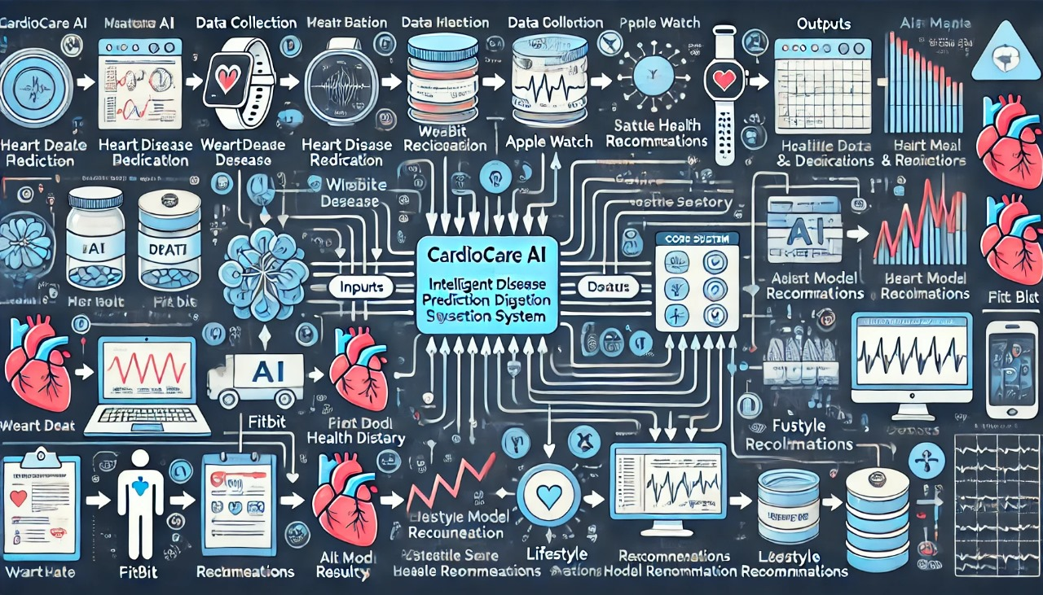

Software Requirements Specification

for

CardioCare

Version 1.0

Prepared by

|  |  |  |
| --- | --- | --- |
| Tayyaba Afzal | 2022-CS-134 | tayyabaafzal957@gmail.com |
| Raveeha Mohsin | 2022-CS-149 | mohsinraveeha@gmail.com |

|  |  |
| --- | --- |
| Instructor: | Samyan Qayyum Wahla |
| Course: | Artificial Intelligence |
| Section: | C |

Contents

1 Introduction 1

1.1 Document Purpose 1

1.2 Product Scope 1

1.3 Intended Audience and Document Overview 1

1.4 Definitions, Acronyms and Abbreviations 2

1.5 Document Conventions 2

1.6 References and Acknowledgments 2

2 Overall Description 3

2.1 Product Overview 3

2.1.1 FlowChart 4

2.2 Product Functionality 5

2.2.1 Admin 5

2.2.2 Patient 5

2.3 Design and Implementation Constraints 6

2.4 Assumptions and Dependencies 6

3 Software Requirements 8

3.1 External Interface Requirements 8

3.1.1 User Interfaces 8

3.1.2 Hardware Interfaces 8

3.1.3 Software Interfaces 8

3.2 Functional Requirements 8

3.2.1 Authentication 8

3.2.2 Functionalities for Admin 9

3.2.3 Functionalities for Patient 13

4 Other Non-functional Requirements 23

4.1 Performance Requirements 23

4.2 Safety and Security Requirements 23

4.3 Software Quality Attributes 23

5 Other Requirements 25

6 Key Performance Indicators (KPIs) 25

7 Time and Cost Considerations 26

Revisions

| Version | Primary Author(s) | Description of Version | Date Completed |
| --- | --- | --- | --- |
| 1.0 | Raveeha Mohsin  Tayyaba Afzal | Initial version of the Software Requirements Specification (SRS) for the CardioCare AI project. This version includes the project's objectives, functionalities, user requirements, non-functional requirements, and appendices. | 2024/10/24 |

# Introduction

CardioCare AI is a comprehensive, AI-powered healthcare system designed to accurately predict and diagnose heart disease. Faced with increasing cardiovascular health issues around the world, especially in places like Pakistan, there is an urgent need for early diagnosis and effective management of heart disease CardioCare AI aims to fill this gap by example raising intelligent predictive models and care recommendations for patients at risk. The system uses real-time health data, advanced machine learning algorithms, and patient-specific data to deliver accurate predictions and recommendations.

## Document Purpose

This Software Requirements Specification (SRS) document provides detailed information about the CardioCare AI: Intelligent Heart Disease Prediction and Diagnosis System, including version and release information of the software being developed Describes the functionality, behavior and limitations of the system exist at the technical and user levels. It defines defined objects. This document focuses on the entire system, including predictive cardiac models, stent prediction, energy requirements, and personalized recommendations The content of this document covers all major aspects of the application ho, including patient and admin roles. It serves as a model for all teams involved in the design, development and implementation of CardioCare AI systems.

## Product Scope

**CardioCare AI** is a healthcare software solution designed to assist in the early detection and management of heart disease. By combining patient-provided health data with real-time input from wearable devices, such as smartwatches, and advanced machine learning algorithms, the system predicts the risk of heart disease, the need for stent placement, and assesses the severity of existing conditions. It also provides actionable recommendations to patients on how to manage their health. The primary goal of the system is to improve the quality of heart disease diagnosis, enable preventive care, and provide personalized health advice. By integrating AI and data analytics, **CardioCare AI** empowers both patients and healthcare providers with reliable and intelligent insights, improving overall heart disease management.

## Intended Audience and Document Overview

The intended audience for this SRS includes developers, project managers, system architects and testing teams who are working on the development of the **CardioCare AI** system. Additionally, it serves as a reference for the **client** and **Professor Samyan Qayyum Wahla** overseeing the project to ensure all functional and non-functional requirements are met. This document is organized into sections that describe the system’s objectives, design, and implementation details. For a logical flow, it is recommended to start with the system overview in the initial sections, followed by specific functional requirements, system models, and user interactions in later sections. Technical personnel can refer to the detailed requirements, while managers and clients can focus on high-level system behavior and scope.

## Definitions, Acronyms and Abbreviations

• **AI**: Artificial Intelligence

• **API**: Application Programming Interface

• **CardioCare AI**: Intelligent Heart Disease Prediction and Diagnosis System

• **CRUD**: Create, Read, Update, Delete (operations on data)

• **IEEE**: Institute of Electrical and Electronics Engineers

• **KNN**: K-Nearest Neighbors (machine learning algorithm)

• **SVM**: Support Vector Machine (machine learning algorithm)

• **SRS**: Software Requirements Specification

• **UI**: User Interface

## Document Conventions

This document follows the IEEE standard format for SRS documents. The body text is written in **Times New Roman** font, size **12**, with single spacing, justified and standard **1-inch margins** throughout. Section and subsection titles adhere to the template's hierarchy, ensuring clear distinction between different levels of content. Italics are used for comments or additional explanatory text. Special terms and acronyms are explained in the **Definitions** section above.

## References and Acknowledgments

• **IEEE SRS Standards**: <https://standards.ieee.org>

• **Acknowledgments**:

* We would like to acknowledge **Professor Samyan Qayyum Wahla** for his invaluable guidance throughout the development of this project. His support and mentorship were instrumental in its success.
* We also extend our sincere thanks to the ***consultants at Punjab Institute of Cardiology (PIC)***, especially ***Dr. Gulfam Hashmi*** and ***Dr. Umair Abid***, whose insights and guidance during the data collection process ensured the relevance and accuracy of our dataset.

# Overall Description

## Product Overview

**CardioCare** is a new, self-contained healthcare solution aimed at improving early heart disease detection and providing personalized recommendations. Unlike existing tools that solely predict whether heart disease is present, CardioCare AI expands functionality by incorporating advanced predictive models for assessing the need for stent placement, determining the severity of the disease, and offering future care recommendations. This system is designed to integrate with wearable devices, allowing real-time health data collection such as heart rate, cholesterol levels, and blood pressure. By leveraging machine learning algorithms, the product intelligently assesses and provides insights to patients and healthcare professionals.

The system interacts with external hardware (wearable devices) and maintains communication with an external database for storing and retrieving patient data. A user-friendly interface allows patients to input their information, receive diagnoses, and access personalized care suggestions. Admins oversee the overall system performance and manage predictive models. The product is envisioned as a standalone application but can be integrated with larger healthcare ecosystems in the future, allowing for broader interoperability with hospital management systems or telemedicine platforms.

### FlowChart

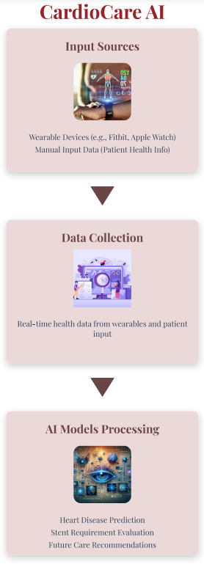





## Product Functionality

CardioCare AI offers several key functionalities that allow users to interact with the system and access AI-driven insights. The following are the major functions:

### Admin

The **Admin** user in CardioCare AI plays a crucial role in managing and overseeing the system's operations. Admin functionalities focus on system health monitoring, model management, and ensuring data accuracy.

* **Dashboard Overview**: Admins can access an overview of system performance, including active users, number of predictions made, and system health metrics.
* **AI Model Monitoring**: Admins can review the performance of the AI models, including accuracy, precision, and recall metrics for heart disease prediction, stent prediction, and severity assessment models.
* **Patient Data Management**: Admins can manage patient records and can view patient health overtime.

### Patient

The **Patient** user interacts directly with the CardioCare AI system to manage their health data and receive AI-driven insights for better heart disease management.

* **Registration & Profile Setup**: Patients can create a profile by providing basic details such as age, weight, gender, family history, and lifestyle factors (e.g., smoking, exercise habits).
* **Health Data Input**: Patients can manually input health metrics such as cholesterol levels, blood pressure, and glucose levels, or sync data from wearable devices for real-time updates.
* **Heart Disease Risk Prediction**: Patients receive a detailed prediction regarding their risk of heart disease based on the input data and the results of advanced AI models.
* **Stent Requirement Prediction**: The system predicts whether a stent may be needed based on the patient’s current health status and past medical data.
* **Severity Assessment**: Provides an estimate of the severity of any detected heart disease, categorizing it into mild, moderate, or severe based on predictive analytics.
* **Narrowing Arteries Detection:** Based on the narrowing of arteries, the system assesses whether medical interventions, such as the insertion of a stent or other treatments, are required, offering recommendations for further diagnostic tests or treatments.
* **Personalized Recommendations**: Patients receive customized health recommendations, including dietary changes, exercise plans, and lifestyle modifications tailored to reduce heart disease risk.
* **Progress Tracking**: Patients can track their health progress over time by comparing new data with historical records, helping them monitor improvements or deterioration.
* **Report Generation**: Patients and admins can generate comprehensive reports summarizing the patient’s heart health, including risk predictions for heart disease, stent requirements, artery narrowing, and lifestyle recommendations. These reports are presented in a clear and user-friendly format.
* **Shareable Medical Records**: The system allows patients to download and share their reports with healthcare providers, ensuring seamless communication and follow-up for further medical interventions or consultations.

## Design and Implementation Constraints

The development of CardioCare AI is subject to several constraints that may impact its design and functionality. These include:

* **Hardware Limitations**: The integration with wearable devices imposes timing and compatibility constraints. For example, real-time data from smartwatches requires low latency and efficient data synchronization.
* **Interfaces to Other Applications**: The system needs to interface with external APIs for data collection and must comply with data sharing protocols.
* **Technology Stack**: The application will use the **UML modeling** to represent system architecture. Additionally, it will utilize **Python** for AI model development and **React** for the frontend interface.
* **Security Considerations**: Handling sensitive patient data requires strict compliance with healthcare regulations for ensuring patient privacy.
* **Database**: Memory and storage constraints due to the volume of health data, requiring optimized storage management. **MySQL** will be used to store our data.

## Assumptions and Dependencies

The success of CardioCare AI is based on certain assumptions and dependencies that could impact its development:

* **Wearable Device Compatibility**: It is assumed that patients will use popular wearable devices (e.g., Smart Watch) that are compatible with our system’s APIs.
* **Accurate Data Collection**: The system relies on accurate data from external sources like wearables and manual patient input.
* **AI Model Availability**: Pre-trained models or model-building frameworks (such as **TensorFlow** or **Scikit-learn**) will be used and are assumed to be accessible for use without significant delays.
* **Compliance with Healthcare Standards**: It is assumed that the system will comply with legal healthcare data protection standards during and after development.

These factors could significantly influence the overall design and implementation of the project if assumptions do not hold or dependencies are delayed.

# Software Requirements

## External Interface Requirements

### User Interfaces

The CardioCare AI system will feature an intuitive, user-friendly interface for both patients and admins. Patients will interact via a **dashboard** that displays health metrics, heart disease risk predictions, and lifestyle recommendations. The interface will include menus for entering health data, integrating wearable devices, and viewing reports. Admins will have a **management dashboard** to monitor system performance, review AI model outputs, and manage patient data. The interface will be **menu-driven** and include clickable buttons and forms for easy navigation.

### Hardware Interfaces

The system interfaces with **wearable devices** like smartwatches to collect real-time heart rate, blood pressure, and other relevant metrics.. The device use basic “read” interfaces to retrieve current data in real-time, feeding it into the system for further processing and analysis.

### Software Interfaces

CardioCare AI integrates with external software, such as a **website** for patients to input data remotely and receive real-time alerts. It also communicates with database **data storage** and model updates, and can allow the patients to download the **reports** and they can further share links for further consultations and analysis.

## Functional Requirements

Functional requirements define the specific behavior and operations the system must perform to meet user needs. These requirements detail how users will interact with the system, the tasks it will execute, and the overall system functionality. In this project, the functional requirements encompass user interfaces, core features like heart disease prediction and severity assessment, and the interaction flows through various use cases for both patients and administrators.

### Authentication

#### Functionality - Authentication (Sign Up / Sign In)

The authentication functionality allows both Admins and Patients to securely access the CardioCare AI platform. Patients and Admins can sign up for new accounts and log in with their credentials to access personalized features.

##### Interface

The **Authentication Interface** includes two primary sections:

1. **Sign Up Form:** For new users, it collects details like email, password, and account type (Admin or Patient).
2. **Sign In Form:** For existing users, it allows them to log in with their email and password.

Each form has error-handling messages (e.g., incorrect password, email not registered)

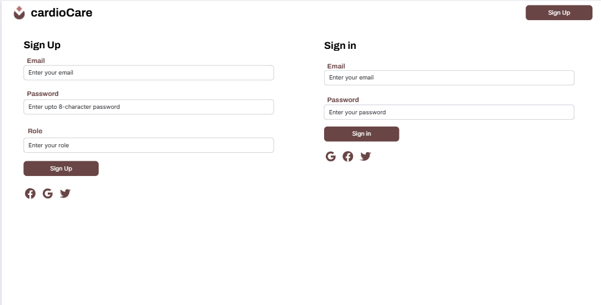

##### Use Cases

* **New User Registration:** Both Admins and Patients can create accounts by providing personal details and selecting their role.
* **User Login:** Registered users (Admin or Patient) can securely log in to their respective accounts.
* **Role-Based Access Control:** After successful authentication, Admins and Patients are redirected to their specific dashboards based on their roles, ensuring they access only role-specific functionalities.

### Functionalities for Admin

#### Functionality - Dashboard Overview

This functionality provides admins with a high-level overview of system activity, including metrics such as active users, prediction counts, and system health data. This helps admins monitor the system’s operational status.

##### Interface

The **Dashboard Overview Interface** displays system performance metrics on a single screen, with charts for active users, prediction history, and system health indicators. This interface includes visual elements like graphs, counters, and alert indicators for easy tracking.

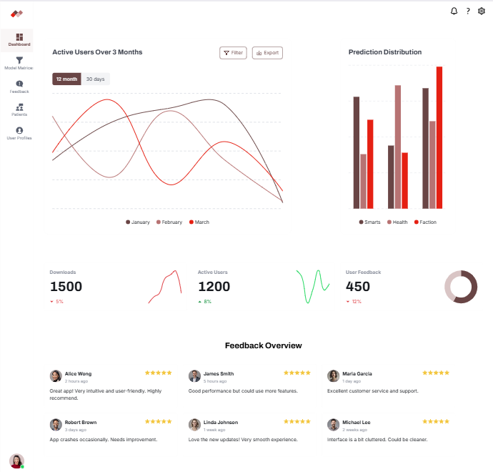

##### Use Cases

* **User Activity Monitoring:** Admins can view the number of active users in real time.
* **Prediction Volume Tracking:** Displays the total number of predictions made within a selected period.
* **Graphical Interface:** It will be a pure graphical interface so that admin can easily analyze the system.

#### Functionality - AI Model Monitoring

Admins have access to insights on the AI models’ performance, including key metrics like accuracy, precision, and recall for models that predict heart disease, stent requirements, and severity levels.

##### Interface

The **AI Model Monitoring Interface** presents performance metrics of each AI model using charts, tables, and statistical summaries. The interface includes dropdowns for selecting specific models and filters for different timeframes.

##### Use Cases

* **Model Performance Review:** Admins can view individual model metrics (accuracy, precision, recall) to evaluate prediction quality.
* **Historical Performance Tracking:** Allows admins to track model performance over time to identify trends.
* **Model Optimization Alerts:** Notifies admins if a model’s performance drops below a defined threshold, signaling the need for retraining or tuning.

#### Functionality - Patient Data Management

Admins can manage patient records, allowing them to view, and monitor health data over time, helping to maintain an accurate and up-to-date patient database.

##### Interface

The **Patient Data Management Interface** includes a searchable list of patient profiles, with options to view individual health data histories. Each patient profile provides charts of health trends and recent data inputs.

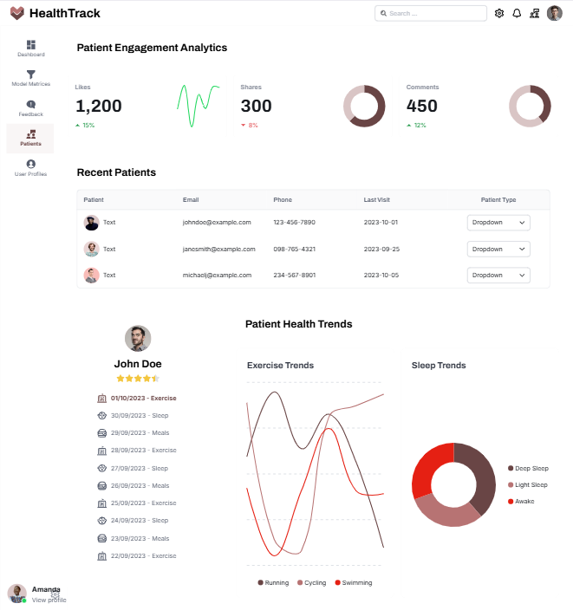

##### Use Cases

* **Patient Record Access:** Admins can search for and access individual patient records.
* **Health Data Review:** Allows admins to view a patient’s health metrics over time for quality control and verification.

### Functionalities for Patient

#### Functionality - Profile Setup

The **Profile Setup** functionality allows patients to create a personalized health profile by entering essential information like their age, weight, gender, family medical history, and lifestyle habits such as smoking and exercise patterns. This data is used to customize risk predictions and recommendations.

##### Interface

The **Profile Setup Interface** will consist of multiple input fields and dropdown menus for easy data entry. Patients will fill out forms to input their personal details, with validation to ensure data accuracy. Buttons like **"Save"** and **"Update"** will allow users to store or modify their profiles.

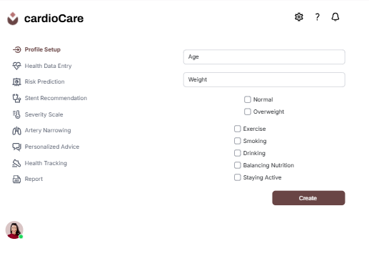

##### Use Cases

* **Create New Profile:**  
  Patients can create a new profile by entering their personal details and lifestyle information for heart disease risk assessment.
* **Edit Profile Information:**  
  Patients can update or edit their details, such as changing weight, adding new lifestyle habits, or updating family history.

#### Functionality - Health Data Input

The **Health Data Input** functionality allows patients to manually enter essential health metrics, including cholesterol levels, blood pressure, glucose levels, and more. This feature also supports real-time syncing of data from wearable devices, ensuring up-to-date health status tracking for accurate analysis and risk prediction.

##### Interface

The **Health Data Input Interface** will feature fields for manual entry of key health metrics such as cholesterol, glucose, and blood pressure. Dropdowns, sliders, or text fields will be used for easy data input, with automatic units of measurement displayed for clarity. The interface will also include a section for syncing with wearable devices, where patients can see their real-time data pulled from connected devices like smartwatches or fitness trackers. There will be options for **"Submit Data"** and **"Sync Wearable"** for easy interaction.

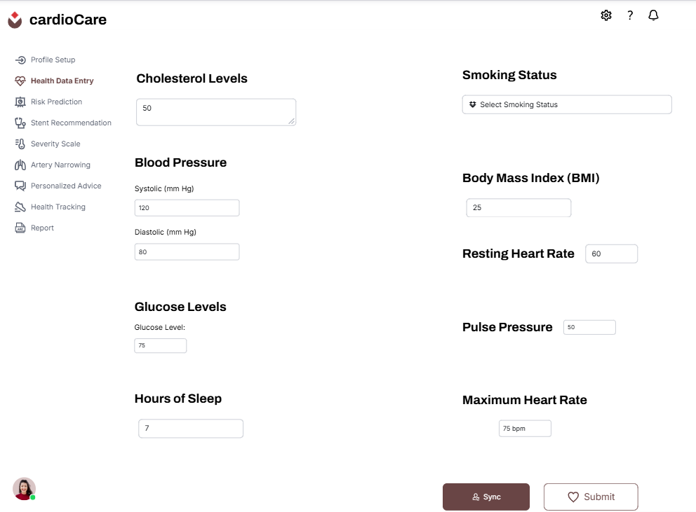

##### Use Cases

* **Manual Health Data Entry:**  
  Patients can manually enter their latest health metrics such as cholesterol, blood pressure, or glucose levels for heart risk analysis.
* **Real-Time Data Sync:**  
  Patients can sync their wearable devices to receive real-time updates on heart rate, blood pressure, and other health metrics directly from their device.
* **Health Metric Validation:**  
  The system will validate the entered health data and alert patients if values fall outside normal ranges, suggesting immediate action if needed.
* **Update Health Data:**  
  Patients can update previously entered health metrics to keep their records accurate and up-to-date.

#### Functionality - Heart Disease Risk Prediction

This functionality provides patients with a detailed prediction of their heart disease risk using AI models. The system analyzes input data such as health metrics, lifestyle factors, and medical history to generate a personalized risk assessment.

##### Interface

The **Heart Disease Risk Prediction Interface** will present a summary of the patient’s risk level in a clear and easily understandable format.

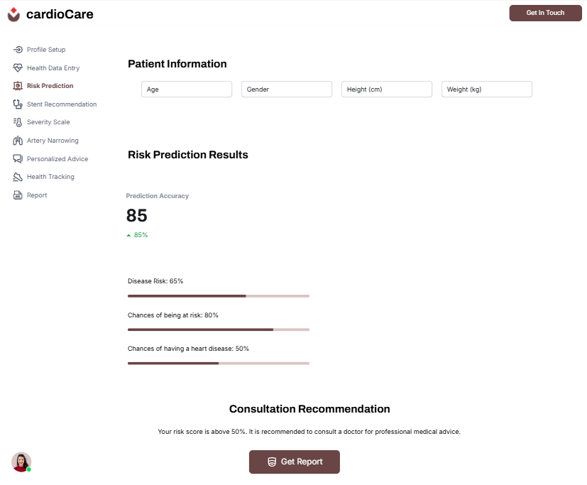

##### Use Cases

* **Risk Analysis:** The system uses AI to process patient data and provide a risk score for heart disease.
* **Recommendation for Doctor Consultation:** If the risk is moderate or high, the system suggests consulting a doctor for further evaluation.

#### Functionality - Stent Requirement Prediction

This feature predicts whether the patient may require a stent based on current health data and historical medical information. The system uses predictive models to analyze factors like blood flow, artery narrowing, and cholesterol levels.

##### Interface

The **Stent Requirement Prediction Interface** will show the likelihood of needing a stent in a binary format.

##### Use Cases

* **Prediction for Stent Requirement:** AI models analyze data to predict if the patient may need a stent.
* **Recommendation for Further Tests:** If the stent is predicted as necessary, the system recommends further diagnostic tests or a specialist consultation.

#### Functionality - Severity Assessment

This functionality estimates the severity of any detected heart disease, categorizing it into mild, moderate, or severe. It uses AI to analyze a patient’s heart health metrics and provide an assessment of disease progression.

##### Interface

The **Severity Assessment Interface** provides patients with a visual scale (e.g., mild to severe) and a detailed report explaining the severity of their condition. A severity score will be shown, along with color-coded indicators to represent the intensity of the disease.

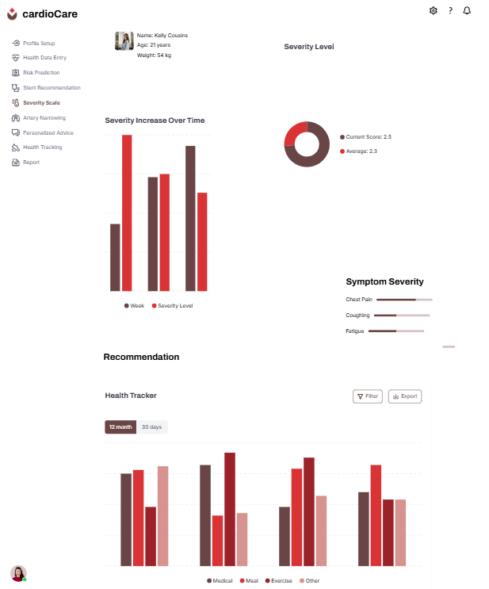

##### Use Cases

* **Severity Score Generation:** AI provides a score indicating the severity of the detected heart disease.
* **Personalized Action Plan:** Based on the severity, patients receive tailored health plans or treatment suggestions.
* **Medical Alert:** If the severity is classified as severe, the system advises immediate medical intervention.

#### Functionality - Narrowing Arteries Detection

This feature assesses the extent of narrowing in the patient’s arteries and predicts whether medical interventions like stent insertion are necessary. It uses AI models to analyze health data and provide recommendations for further tests or treatments.

##### Interface

The **Narrowing Arteries Detection Interface** presents a clear assessment of the artery conditions, showing the percentage of narrowing detected. It also provides suggested actions such as scheduling diagnostic tests or recommending treatments.

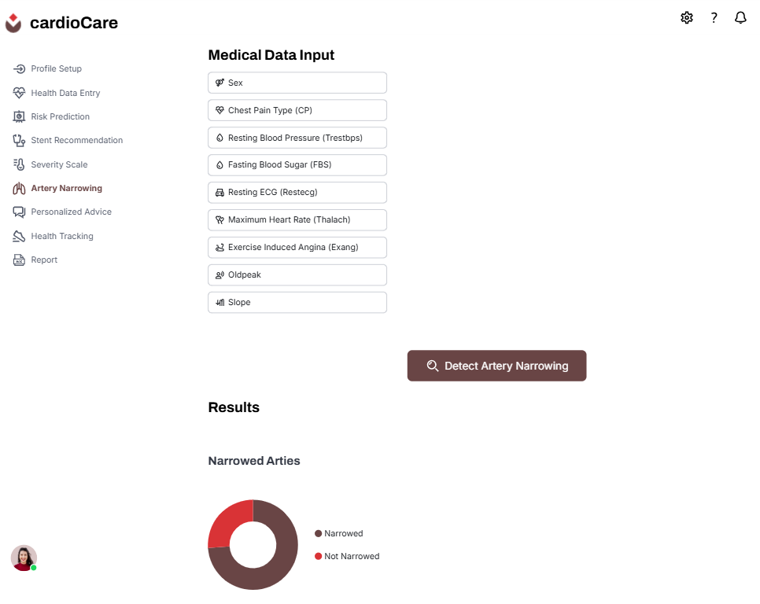

##### Use Cases

* **Artery Narrowing Detection:** The system detects and quantifies the extent of artery narrowing.
* **Treatment Recommendations:** Based on the narrowing, the system recommends medical interventions or lifestyle changes.
* **Notification for Specialist Referral:** If significant narrowing is detected, the system advises seeking specialized medical care.

#### Functionality - Personalized Recommendations

This functionality offers patients tailored recommendations to help lower heart disease risk. Based on individual health metrics, the system provides customized advice on dietary adjustments, exercise routines, and lifestyle changes.

##### Interface

The **Personalized Recommendations Interface** will display tailored suggestions for lifestyle improvements in an easy-to-read list format. Recommendations will be organized by categories such as diet, exercise, and daily habits, with icons to visually differentiate each.

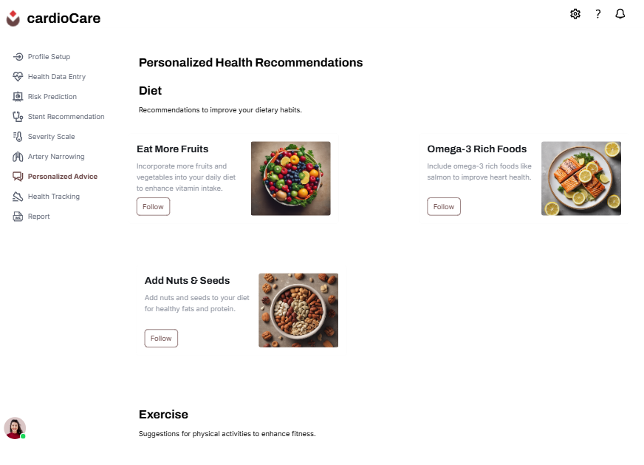

##### Use Cases

* **Customized Health Plan:** The system generates a plan based on the patient's health data and risk factors.

#### Functionality - Progress Tracking

Patients can track their health over time, comparing recent data with past records to assess any improvements or deteriorations in their heart health. This functionality provides visualizations of health trends.

##### Interface

The **Progress Tracking Interface** displays historical data in graphs and charts to show trends over time. Health metrics such as cholesterol levels, blood pressure, and exercise activity are visually represented, allowing patients to easily understand their progress.

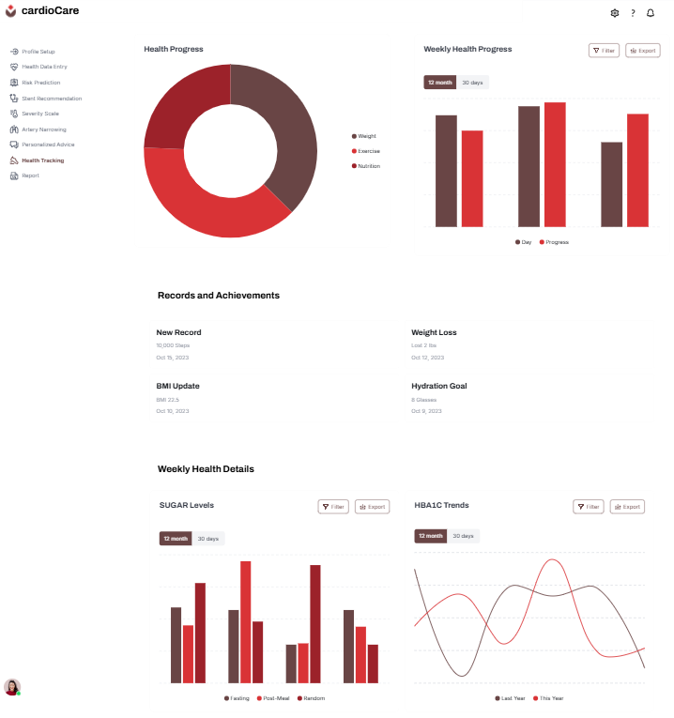

##### Use Cases

* **Health Metrics Visualization:** Patients view changes in their metrics over time using charts and graphs.
* **Achievement Highlights:** The system highlights milestones, like improved cholesterol levels or lowered blood pressure.
* **Alert for Decline:** If any metrics significantly worsen, the system notifies the patient to encourage prompt action.

#### Functionality - Report Generation

This functionality allows patients to generate detailed reports summarizing their health data, risk predictions, and recommendations for future action. The report can be shared with doctors or healthcare providers for further analysis.

##### Interface

The **Report Generation Interface** provides options to create downloadable PDF reports containing health summaries, risk predictions.

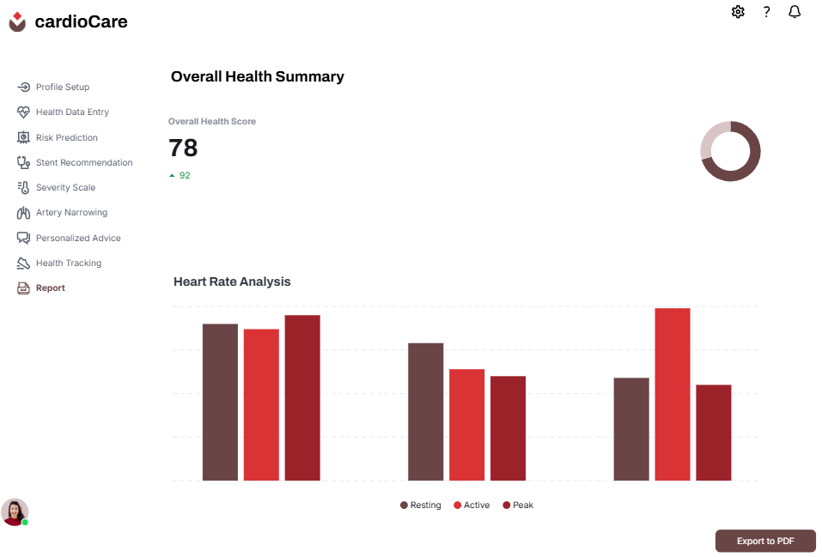

##### Use Cases

* **Customized Report Creation:** Patients can generate a report that summarizes their heart health and AI-driven risk assessments.
* **Sharing with Doctors:** The report can be easily shared with healthcare providers to facilitate further diagnosis or treatment planning.
* **Health Progress Tracking:** The report helps patients track changes in their health metrics over time.

#### Functionality - Shareable Medical Records

This feature allows patients to download or share their health records and reports, making it easier to communicate with healthcare providers for further medical consultations or follow-up treatments.

##### Interface

The **Shareable Medical Records Interface** provides an option to generate a PDF report containing the patient's health data, risk assessments, and recommendations. The interface includes buttons for downloading, or sharing the report securely.

##### Use Cases

* **Report Generation and Sharing:** Patients can generate a comprehensive health report that can be shared with healthcare providers.
* **Downloadable Format:** The system creates downloadable PDF files for easy storage and access.
* **Secure Sharing Options:** Patients have the option to share reports directly with their doctors, maintaining confidentiality and data integrity.

# Other Non-functional Requirements

## Performance Requirements

The performance requirements for CardioCare AI focus on providing accurate, timely predictions and a responsive user experience across various conditions:

* **P1. Response Time:** The system should provide initial heart disease risk predictions and related results within **5 – 10 seconds** of receiving user input data, otherwise a loading spinner should be shown.
* **P2. Real-time Data Sync:** When connected to wearable devices, the system should synchronize health metrics in **real-time** or with a **maximum delay of 5 - 15 seconds**, till then a spinner will be shown.
* **P3. Data Processing Speed:** For more complex assessments like severity analysis or stent requirement prediction, processing should not exceed **10 seconds** under normal system load.

## Safety and Security Requirements

CardioCare AI is built to ensure the highest levels of data protection and secure user interactions:

* **S1. Patient Data Privacy:** All personal health information and medical records must be secured and can’t be updated or changed without patient’s permission.
* **S2. Access Control:** Admin and Patient roles have specific access rights, enforced through role-based access control ensuring patients cannot view administrative dashboards and admins cannot access confidential patient data unless permitted.
* **S3. Data Integrity Checks:** Regular integrity checks will be implemented to ensure no unauthorized modifications are made to the patient data stored within the system.

## Software Quality Attributes

**4.3.1 Reliability**

* **Requirement:** CardioCare AI should ensure 99.9% uptime for core functionalities, including health predictions and data management.
* **Implementation:** To achieve this, a database, distributed architecture will be used with automated backup and recovery processes to prevent data loss or prolonged outages.

**4.3.2 Usability**

* **Requirement:** The system should provide an intuitive user interface with clear instructions and easy navigation, enabling first-time users to set up their profiles or access predictions with minimal guidance.
* **Implementation:** This will be achieved through a well-structured UI design, tooltips, and an accessible layout. The interface will also undergo usability testing with users for feedback.

**4.3.3 Maintainability**

* **Requirement:** CardioCare AI should be designed for maintainability, allowing for easy updates or changes to algorithms and interface components.
* **Implementation:** The system will use modular design principles, making individual features like prediction models, data input forms, and reports easy to update independently without affecting other parts of the system.

**4.3.4 Security (Specific to Data Storage and Access)**

* **Requirement:** Only authorized users should be able to access specific sections of the system (e.g., Admins for system management, Patients for personal reports).
* **Implementation:** Multi-factor authentication will be required for admin users, and sensitive patient data access will require additional authorization steps to ensure no unauthorized access.

# Other Requirements

This section outlines additional requirements for CardioCare AI:

* **Database Requirements:** Data should be stored securely , allowing for easy retrieval and efficient querying to support rapid AI predictions.
* **Reusability:** Components of the system, especially AI models and data handling modules, should be designed for potential reuse in other healthcare applications.

# Key Performance Indicators (KPIs)

The success of CardioCare AI will be measured by specific Key Performance Indicators (KPIs) to ensure system effectiveness and quality of output. These KPIs focus on accuracy, data integration, and value-added features for patient care.

1. **Hospital Data Integration Rate**
   * **Objective**: Successfully integrate and process live data from hospital datasets to deliver real-time analysis.
   * **Measurement**: Percentage of live hospital data integrated into the system without errors.
   * **Target**: 85%+ successful data integration rate.
2. **Accuracy of Report Generation**
   * **Objective**: Generate accurate, detailed reports based on AI analysis for patient and administrative review.
   * **Measurement**: Percentage of reports free from errors, with correct predictive analysis and data representation.
   * **Target**: At least 80% accuracy in reports.
3. **Timeliness of Personalized Recommendations**
   * **Objective**: Provide patients with actionable, personalized health recommendations based on their health data and AI insights.
   * **Measurement**: Average time taken to generate recommendations following data input or report generation.
   * **Target**: Recommendations generated after data input or report completion.

These KPIs will guide the ongoing development and refinement of CardioCare AI to ensure it meets the needs of patients, healthcare providers, and administrative staff.

# Time and Cost Considerations

Implementing CardioCare AI involves a significant investment in both time and resources due to the advanced functionalities and integrations it provides, such as data synchronization with wearable devices and hospital visits for data collection. Here is an outline of major cost and time factors:

1. **Wearable Device Synchronization**
   * **Cost**: Integrating data from wearable devices involves some costs for software development and testing to make sure everything works well together.
   * **Time**: Expect to spend about 2-3 weeks on this part, focusing on connecting the devices and ensuring real-time data updates.
2. **Hospital Data Integration**
   * **Cost**: Setting up connections to receive live data from hospitals may require some investment in software and data security measures.
   * **Time**: Plan for around 3-4 weeks to set up and test the data connections with hospitals.
3. **AI Model Development**
   * **Cost**: Building and training AI models will require some budget for software tools and possibly hiring or consulting with experts in AI.
   * **Time**: You should aim to spend about 3-4 weeks developing the models and testing them with real data.
4. **Data Privacy and Compliance**
   * **Cost**: Ensuring that your system meets data privacy laws will need some investment in security features and possibly legal advice.
   * **Time**: Allocate about 1-2 weeks to review and implement necessary security measures.

By focusing on these areas and managing your time carefully, we can successfully complete the CardioCare AI project within the next two months.

Appendix A – Data Dictionary

The following table outlines the key variables, constants, state variables, inputs, and outputs used in CardioCare AI, along with descriptions, operations, and any related requirements.

| **Item Name** | **Type** | **Description** | **Possible Values / States** | **Operations** | **Related Requirements** |
| --- | --- | --- | --- | --- | --- |
| PatientID | Identifier | Unique identifier for each patient | Numeric ID | Retrieve, assign | Patient data management |
| AdminID | Identifier | Unique identifier for each admin | Numeric ID | Retrieve, assign | Admin functionality, authentication |
| Age | Input | Patient's age | Integer (e.g., 0-120) | Input, validate | Profile setup, prediction model input |
| Gender | Input | Patient's gender | "Male", "Female", "Other" | Input, validate | Profile setup, prediction model input |
| CholesterolLevel | Input | Patient's cholesterol levels | mg/dL (e.g., 100-300) | Input, validate | Health data input, prediction analysis |
| BloodPressure | Input | Patient's blood pressure | mm Hg (e.g., 80-180) | Input, validate | Health data input, prediction analysis |
| HeartRiskScore | Output | Predicted risk level for heart disease | Yes, No | Calculate, display | Heart disease risk prediction |
| SeverityScore | Output | Predicted severity level for detected conditions | Mild, Moderate, Severe | Calculate, display | Severity assessment |
| StentPrediction | Output | Likelihood of stent requirement | "Required", "Not Required" | Predict, display | Stent requirement prediction |
| FamilyHistory | Input | Indicator of heart disease in family history | Yes, No | Input, validate | Profile setup, prediction model input |
| LifestyleFactors | Input | Factors like smoking or exercise habits | Boolean values (True/False for each factor) | Input, validate | Profile setup, health recommendation analysis |
| AIModelAccuracy | Metric | Performance accuracy of the AI models | Percentage (0-100%) | Monitor | AI model monitoring |
| SystemHealthStatus | State Variable | Overall health status of the CardioCare AI system | "Optimal", "Warning", "Critical" | Monitor, alert | Dashboard overview for admins |
| AuthToken | State Variable | Security token for session authentication | Alphanumeric | Generate, validate | Authentication and user sessions |
| ReportGenerated | Output | Generated health report for patient | PDF document | Generate, download | Report generation and sharing |
| Recommendations | Output | Personalized health advice for lifestyle improvements | Text recommendations | Calculate, display | Personalized recommendations |
| ProgressData | Output | Historical health data for tracking patient progress | Time series data | Retrieve, display | Progress tracking |

This data dictionary provides an overview of the core elements within CardioCare AI, supporting both functionality and requirements outlined in this SRS.

Appendix B - Group Log

This section documents the group’s meeting minutes, activities, and progress throughout the development of the CardioCare AI project.

| **Date** | **Meeting Type** | **Attendees** | **Discussion Points** | **Actions & Decisions** |
| --- | --- | --- | --- | --- |
| 2024-09-29 | Initial Project Meeting | All team members | Project scope, initial role assignments, and brainstorming on core functionalities and objectives | Defined roles, identified initial features, and set weekly meeting schedule |
| 2024-10-02 | Requirement Gathering | All team members | Discussed user needs, system requirements, and functional requirements | Finalized system requirements and functional features |
| 2024-10-17 | Visit to Punjab Institute of Cardiology | All team members | Discussed with doctors about the data.. | Gathered the data from hospital. |
| 2024-10-10 | Formal Proposal | All team members | Discussed the key features of proposal | Designed the formal proposal |
| 2024-10-24 | SRS Meeting | All team members | Reviewed completed SRS document, discussed any final adjustments or additions | Approved SRS document for submission |

This group log summarizes key meetings, decisions, and activities, showcasing the collaborative effort in creating this SRS document. Further notes on individual contributions and any additional meetings are available upon request.